Protist Evolution Assignment

Go here: http://www.sumanasinc.com/webcontent/animations/content/organelles.html
Click on "Narrated". Watch the video.

Go here: http://evolution.berkeley.edu/evosite/history/endosym.shtml
Read the article, both pages.

1. What role did Lynn Margulis play in the theory of endosymbiosis?

2. What role did Woese and Doolittle play in the theory of endosymbiosis?

3. What hypothesis proposed by Margulis has not been widely accepted?

4. How is this relevant to modern science?

Protists Transport

5. How do protists transport oxygen and carbon dioxide?

6. How do protists transport wastes and ions?

7. How do protists maintain water balance?

8. Discuss the differences in transport systems of unicellular protists, colonial
protists and large multicellular protists, such as brown algae.

Phylogenetic Tree for Protists

Use the cladogram on the next page (Campbell, 8th edition, page 578) to answer the next questions.

9. Which protist group is the sister taxon of plants?

10. Which protist group is the sister taxon of animals?

11. Which protist group is the sister taxon of fungi?

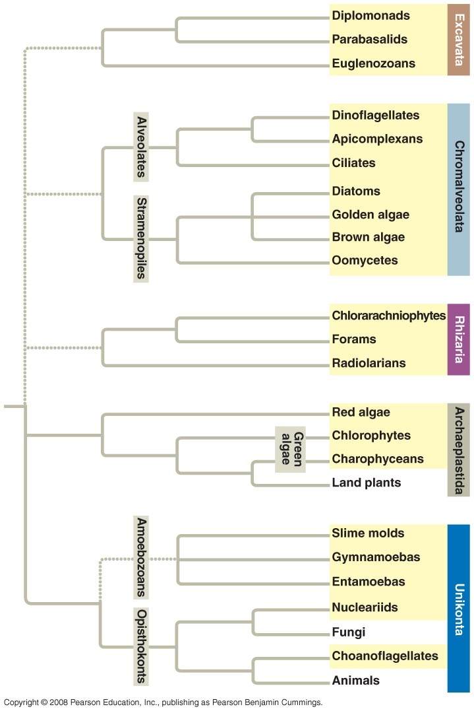

Further Explorations

ABC Hypothesis
Go here: http://www.astrobio.net/news/article243.html

1. Explain Hartman's ABC hypothesis. Include the following:
a. What are eukaryotic signature proteins?
b. What is a chronocyte?
c. What eukaryotic structures did the chronocyte have that were not found in
archaeans and bacteria?
d. Based on his hypothesis, where did the nucleus come from?
e. What appears to be the significance of horizontal gene transfer in the
evolution of life?

2. Think about Lipps' comments about basing a tree on one molecule. Relate his
comments to the lab that we did on relatedness.

